Grade 11 English FAL Week 25 May to 28 May 2020

Day 1 – Worksheet 1: Comprehension (advertisement)
Day 2 and 3 – Worksheet 2: Writing (advertisement)
Day 4 – Worksheet 3: Language (modal verbs)
Day 5 – Aftercare (mark work using the memoranda on Google Class uluo2tl.

Worksheet 1: Comprehension - Advertisement (1 day)

Advertisements are intended to convince you
of the value of a brand (i.e. to build the image of a company, institution or organisation);
to buy a product or service;
to support an organisation or idea, or to take some kind of action (e.g. start exercising).
A good advertisement will
A – attract your attention;
I – keep you interested;
D – cause desire in you to take action;
A – cause you to take action.
Advertisements are always aimed at a specific target audience (gender, age, income level, educational level), often dictated by the product or idea advertised, e.g. an advertisement for a popular, but expensive brand of clothing is likely to be aimed at upper-income individuals below the age of 24. Everything in the advertisement will be tailored to appeal to this target audience.
Devices used in an advertisement
Visual devices include pictures, graphics and fonts (choice of font, size and boldness).
Literary devices include irony, hyperbole, the use of puns, metaphors, similes and rhyming devices (especially alliteration and assonance).
Persuasive techniques such as endorsement by experts or popular figures, what appears to be scientific evidence, the desire of individuals to be accepted members of a group and plays on other emotions.
Exercise
Study the advertisement below and answer the questions on it. Do not rush! Take time to consider the questions and provide full answers. In an exam the length of your answer will be guided by the mark allocation. Here you are learning about advertisements, so be thorough.
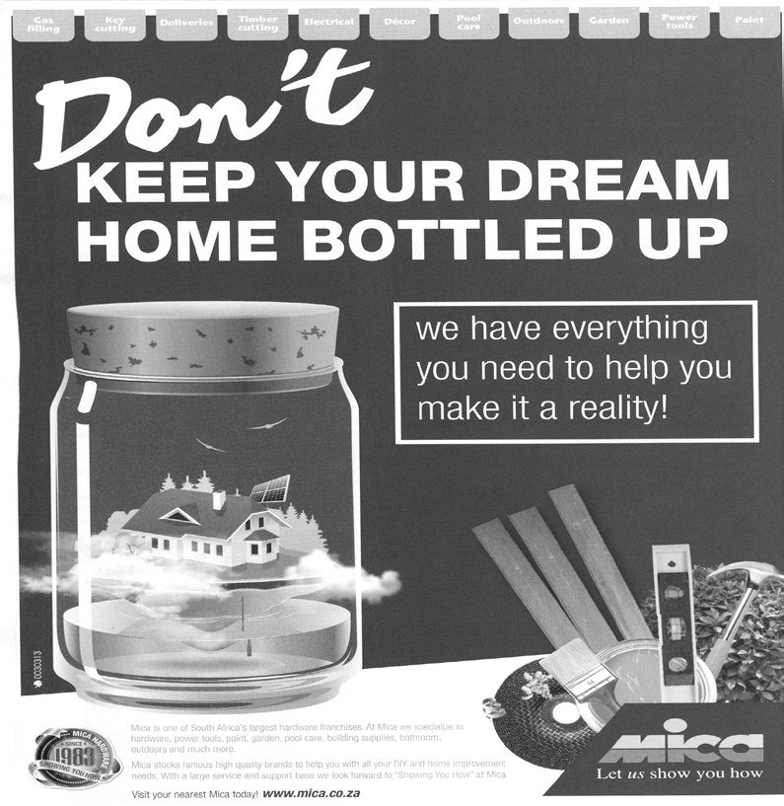

Tabs at the top: Gas filling, key cutting, deliveries, timber cutting, electrical, décor, pool care, outdoors, garden, power tools, paints.
Text on advertisement: Mica is one of South Africa’s largest hardware franchises. At Mica we specialise in hardware, power tools, paint, building supplies and much more. Mica stocks famous high quality brands to help you with all your DIY and home improvement needs. with a large service and support base, we look forward to “Showing You How” at Mica.
Visit your nearest Mica today! www.mica.co.za
Questions
- Describe Mica’s logo.
- Identify the company’s slogan and say what is suggested by it.
- Refer to the heading: “Don’t keep your dream home bottled up.”
3.1 Say what is normally referred to as being “bottled up” in English.
3.2 Identify the figure of speech in this heading.
3.3 Say what fictional character is referred to by this heading.
3.4 Comment on how effective this heading is.
- Identify the target audience of this advertisement and give a reason for your answer.
- Comment on how effective the visuals in the advertisement are. Do not be vague.
- Using the AIDA principle, comment on how effective this advertisement as a whole is likely to be.
6.1 Does it catch your attention and why?
6.2 Does it create interest and how?
6.3 Does it create desire and how?
6.4 Does it allow and encourage you to act on the advertisement and how?
- Name four products one can purchase at Mica.
- Suggest what the tabs at the top of the advertisement could be used for in an on-line advertisement.
- Could Mica be referred to as a speciality store? Refer to the text to justify your answer.
- Do you think the advertisement could be seen as culturally biased? Explain.
Worksheet 2: Writing an advertisement (2 days)
You have decided to offer the public a useful service. Create an advertisement for this service. Your advertisement should contain 80 to 100 words. While you are allowed to include visual elements, only your text will be assessed in a formal assessment. Remember that bold letters are also a visual attention-grabbing device.

Day 1 : Planning and first draft. Use the AIDA abbreviation to do your planning, e.g. Attention – get attention with bold, attention grabbing heading, “Want me to fly you to the moon?”, Interest – grab interest by offering a solution to problems experienced by parents in a sub-heading, “I cannot, but I can babysit while your partner does the flying”, Action – people can respond as I have included contact details. Include a logo and slogan. Give your service a catchy name, e.g. Niknak Nanny. Take care to include the right number of words. Define your target audience and think of what style of advertisement they would respond to.
Day 2: Editing of first draft and final draft. Do not only check for grammar mistakes. Think of how you can make your final draft more expressive, using adjectives, adverbs, emotive language and literary devices. Put yourself in your target audience’s shoes. If you were them, would you respond to the advertisement.

Worksheet 3 : Language – Modal Verbs (1 day)

Modal verbs are a group of auxiliary verbs (they are usually used together with other verbs rather than on their own). Examples include: can, could, may, might, must, shall, should, will, would. They govern the verb they are used with, e.g. in the case of “may” indicating that an action is optional, while in the case of “must” it is compulsory.
Exercise
Choose the correct modal verb from the choices in the brackets below:
- If I study hard, I (must/may) pass the exam.
- I (can/must) not harm my body by being reckless concerning my diet.
- If I lived in the time of the plague in 1820, I (might/would) have avoided unnecessary physical contact with other people.
- When the lockdown is eased, I (can/will) wear a facial mask to avoid breaking the law.
- On condition that I do not fall ill, I (will/must) visit you as soon as possible.
- In the event that I do well in my exams, I (may/must) apply to go to university to complete my chosen course.
- Whenever my friends play pranks, I (can/should) consider whether it could cause them or other people harm.
- Every time I do my homework, I remember that it (will/might) give me valuable practice.
- Whether my friends remember to do so or not, I (must/should) exercise a little bit every day.
- If I could choose, I (will/would) make the best of every situation.
Note how “if”, “whenever”, “every time”, “in the event” and “on condition that” add conditionality to a sentence (one thing will or may happen if another does). Can you think of any other words that do this in a sentence? If so, list them.

Visit your nearest Mica today! www.mica.co.za Name ONE service and ONE product available at Mica. | (2)

